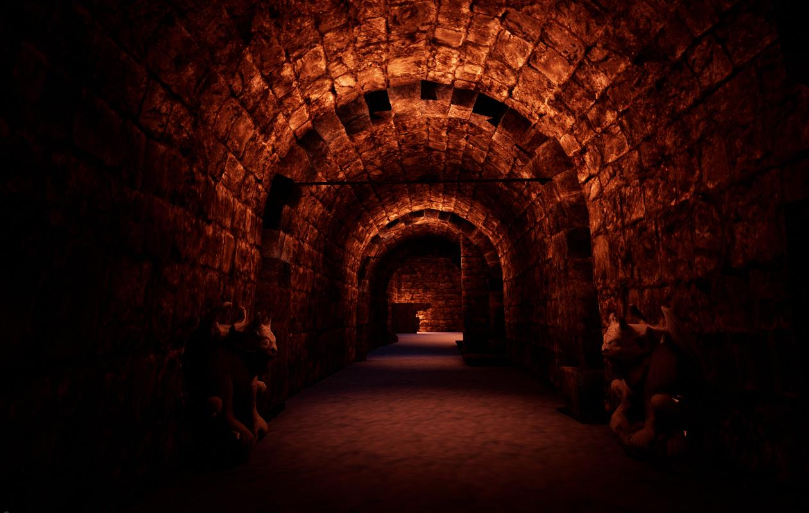

Turok

Cave of Horrors

Design by Cían Daly

For Windows, Mac, Linux

**Ages:** 8 – Up

**Ship Date:** 3/05/2019

**Game Story Summary:** Mathew Cole, a college student with a passion for spelunking, discovers rumours of a cave with supposedly lost treasure somewhere within. Unknown to him is the caves dark history and secret deep within. When trying to leave he discovers the entrance has caved in, his only hope of escape lies further within the cave but can Mathew survive its horrors?

**Game Flow Outline:** Cave of Horrors is a first-person exploration horror experience that finds Mathew Cole searching through Turok cave, located in Eastern Europe. The cave has rumours of a dark past and of being haunted by otherworldly creatures. You will need to be careful if these rumours are true as Mathew, while confident and strong from the years of caving, is not a fighter and will have to employ other tactics to overcome possible challenges.

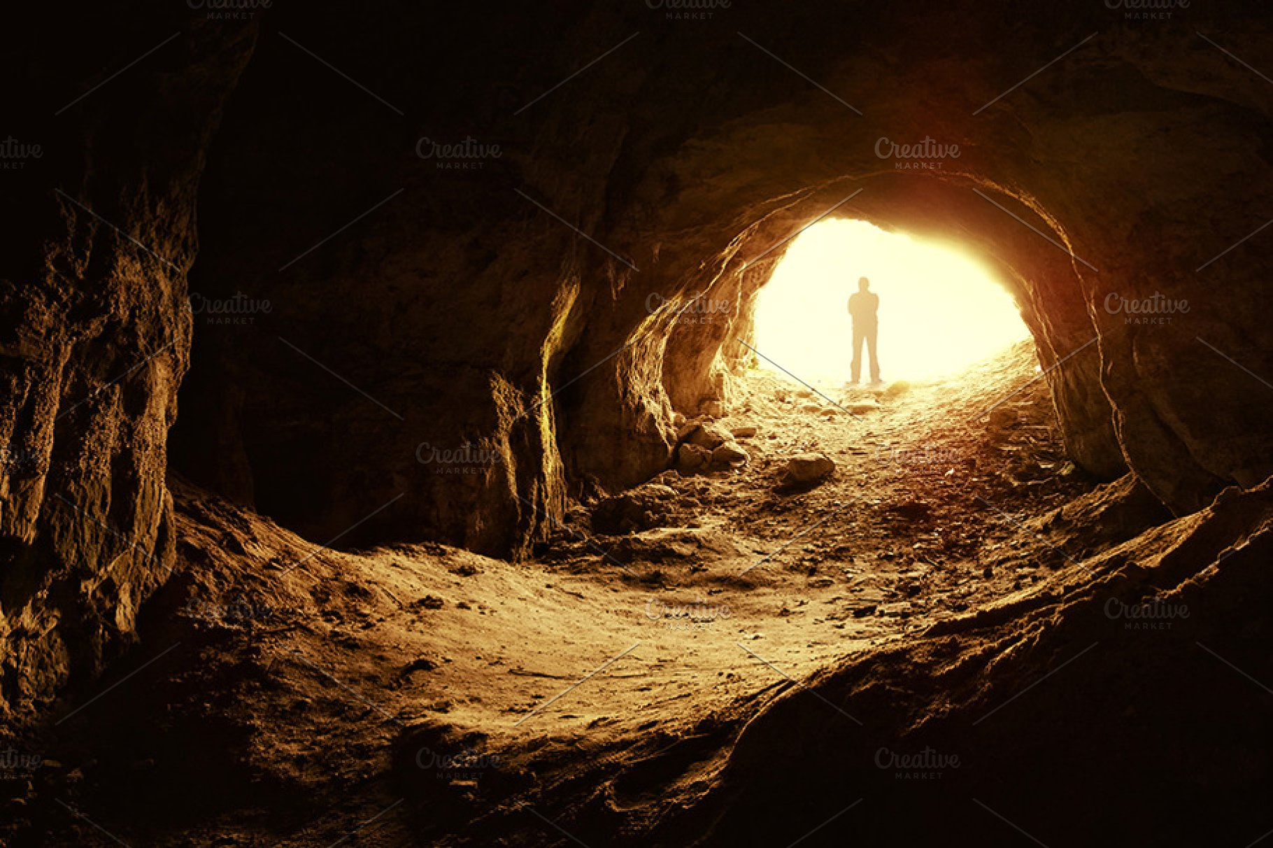

**Character:** Mathew Cole is an aspiring speleologist. He fell in love in with geography and especially caves and their formation through his father who brought him during his childhood to caves and spelunking trips. He does not shy away from a challenge and is eager to make a discovery that will allow his name to be remembered throughout history.

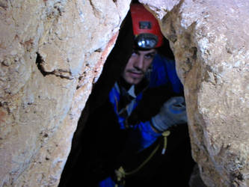

**Controls:** Cave of Horrors uses the following keyboard and mouse controls to play;

* W, A, S, D or up, left, down, right arrow keys to move forwards, left, backwards and right respectively.
* Spacebar to jump
* Left shift to run
* Mouse to move camera/player view
* Left-click to select UI buttons

**Gameplay:** Cave of Horrors is an exploration horror game, where the player must collect a certain amount of keys to escape through the guarded door within a limited time frame. In the catacombs of the cave he will find that the rumours are true and that demonic beings reside here.

All of the controls in Cave of Horrors are optimized for keyboard and mouse. Default keyboard inputs provide basic movement functions while the mouse is used to navigate menus and acts as the player’s eyes.

There is the first audio scare before entering the enemy area where the player will have to avoid the patrolling creature before escaping through the tunnel with the final key.

**Game World:** The game is set as a singular exploration level with two areas, the upper cave area and deeper underground the catacombs where enemies reside.

The background music creates an apprehensive atmosphere and changes depending on which game scene the player is currently on; menu, main level, game over, game complete.

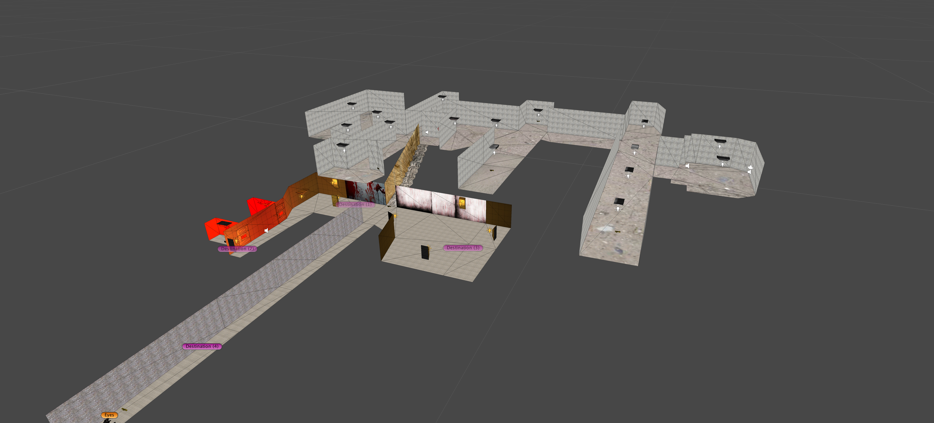

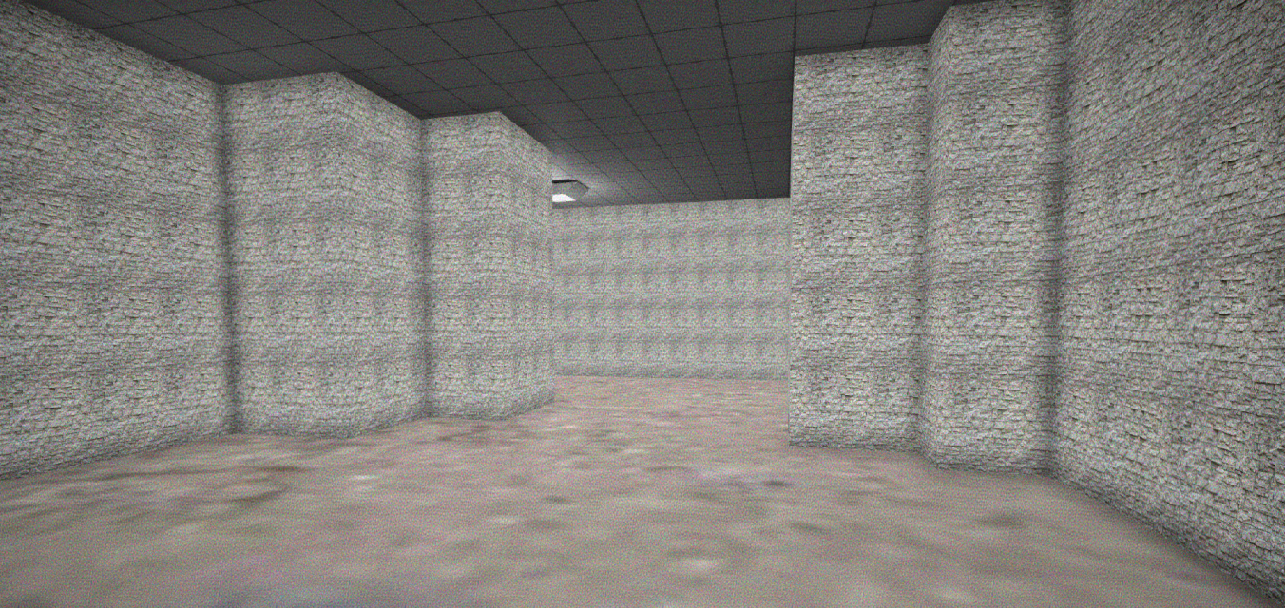

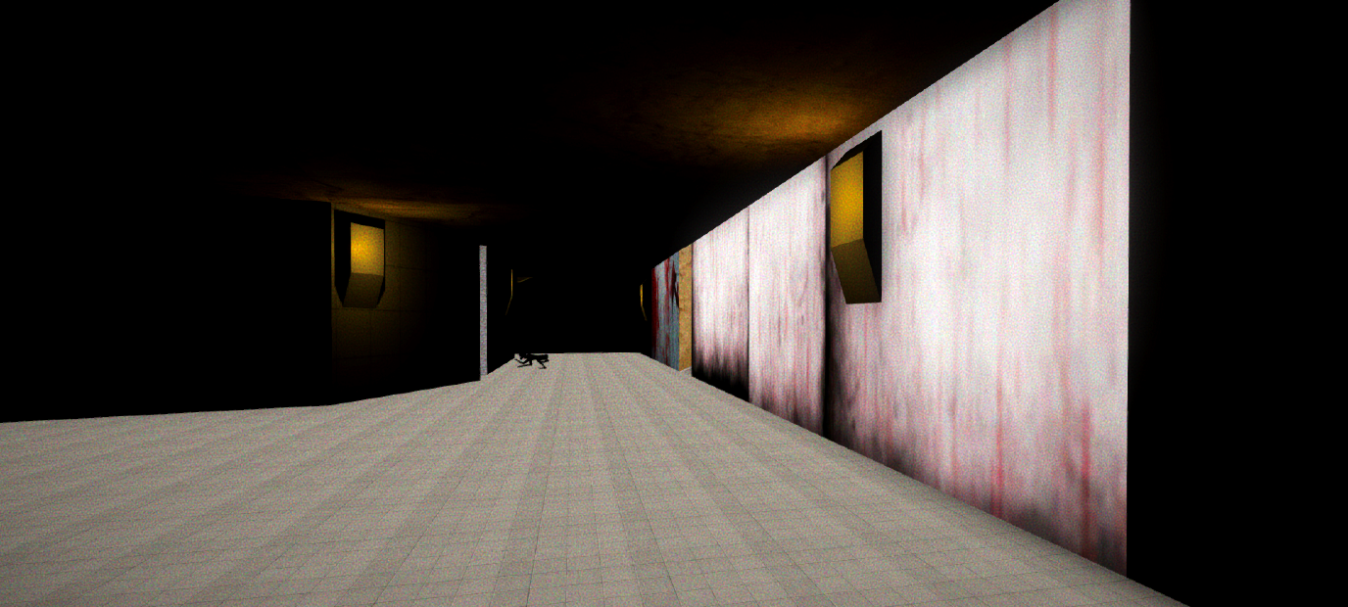

**Game Experience:** After the Unity logo appears the player is taken to the start screen. The player will have three options; Play, Options, Quit. Play starts the game. Options shows a new menu containing customizable game settings for graphics and sound. Quit exits the application.

A background image of a shadowy tunnel with white overhead lights conveys the dark and claustrophobic setting, coupled with blood red text immediately sets the overall tone of the game.

The world of Turok: Cave of Horrors is not on the same level of fear as experienced in *Outlast* but similar to that of *Slende*r. The player should be in a foreboding state when going around corners and searching through the level. The image of a tunnel with only being able to go forwards is emphasized when the player begins the game as all other routes are blocked by cave walls.

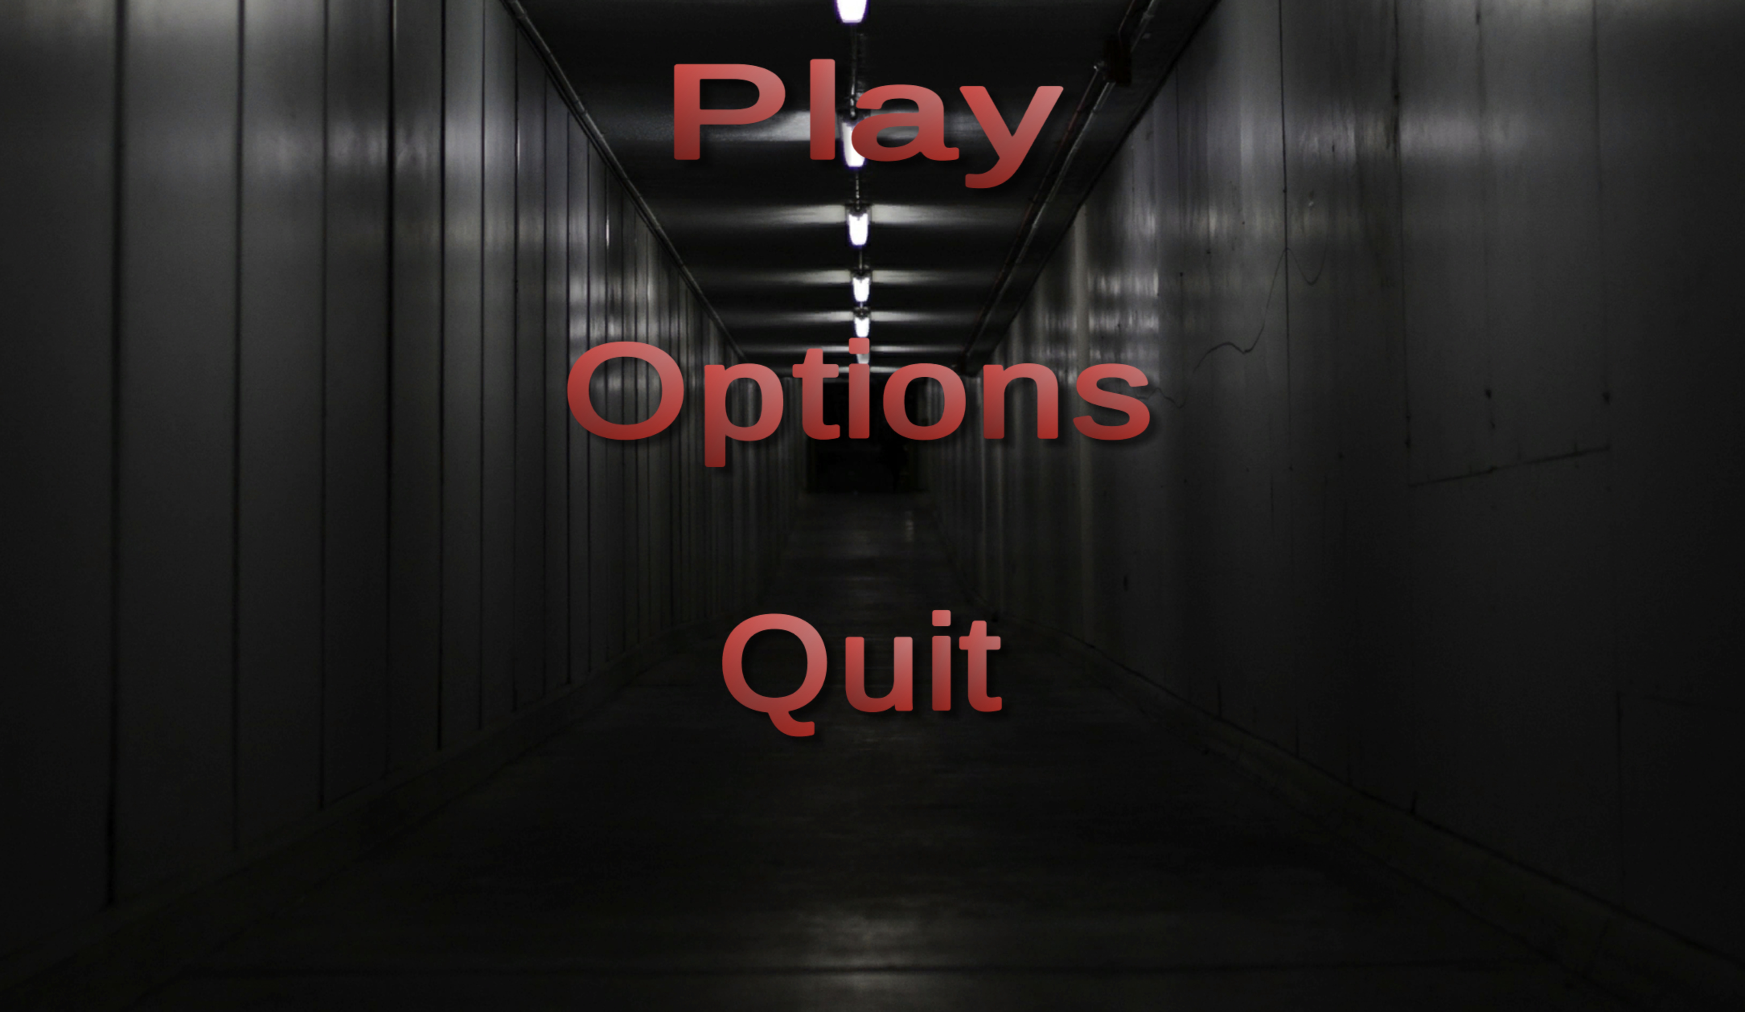

The music in Turok: Cave of Horrors should be sombre, accentuated by short and sharp crescendos. Varying soundtracks of similar tempos should be used based on what situation the player is in and should not feel less impactful upon multiple playthroughs.

**Game Mechanics:** There are no mechanics and only 1 hazard as the focus is exploration and suspense.

**Hazards:** Timer.

**Enemies:** Mathew will discover some AI enemies, a demonic crawling creature guarding a key and some enemies contained in holding cells.

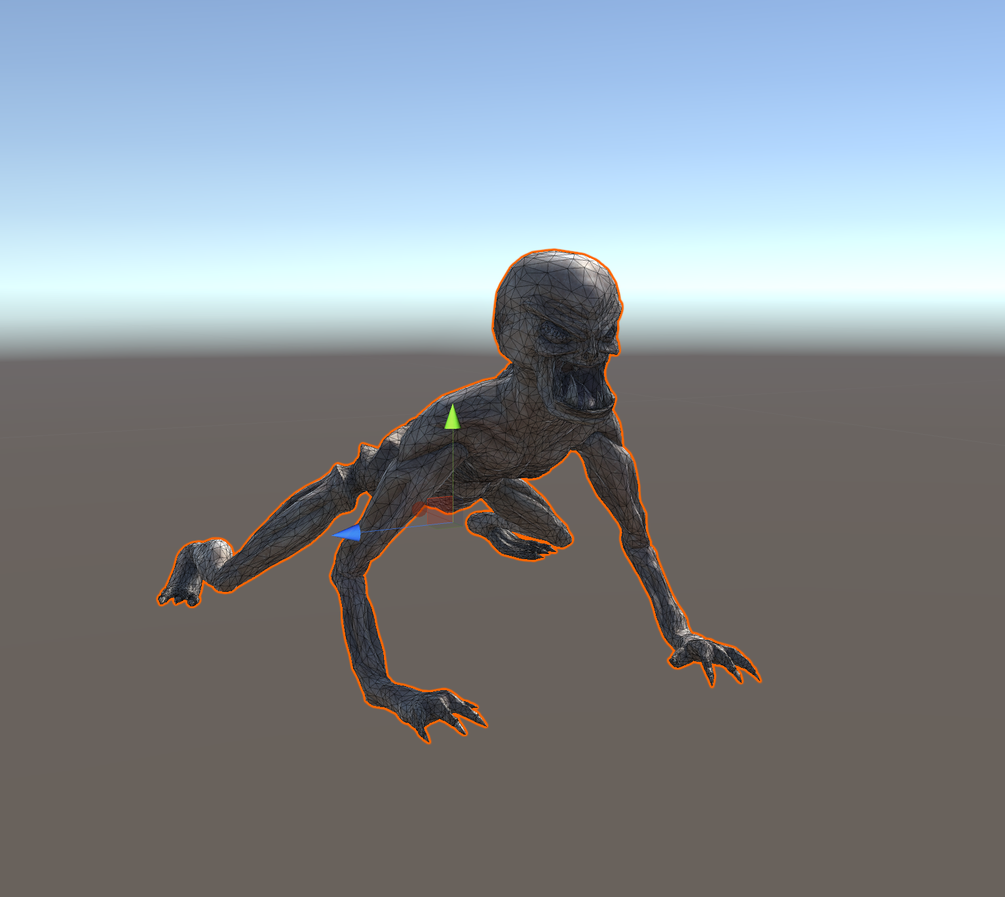

The player is not able to defeat them and must escape when discovered before they kill him.

There are no boss enemies in this game.

**Multiplayer and Bonuses:** The game has no multiplayer and is exclusively single player. There is only one map and it is not possible for fan made maps to be created and published.

Players that pre-order will receive a cd showing behind the scenes creation of the game and an art book containing concept art of aspects of the game.

**Achievements:** There will be achievements for the player to acquire while playing to showcase on their profile.

These do not provide in-game benefits.

**Monetisation:** Turok: Cave of Horrors will be a paid game (est. €12), players will not be able to buy micro-transactions but will be able to purchase dlc packs of additional caves to explore and will provide the backstory of how these enemies came to be and their purpose.

These dlc packs will cost €4.99 each and will introduce new hazards, mechanics and enemies to encourage players to return and continue playing. Three to five dlc packs are planned to be released post launch.